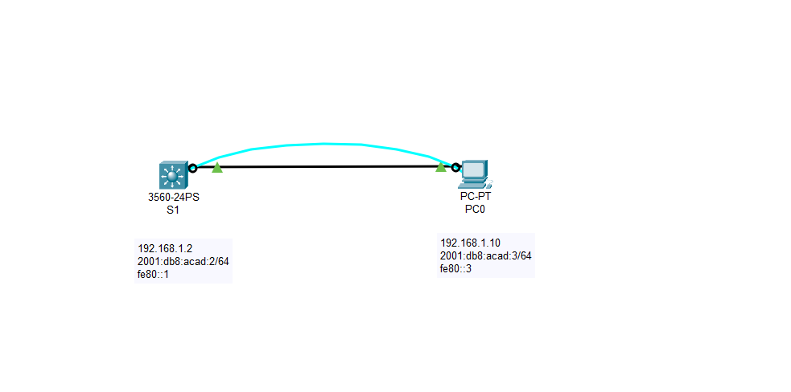

Switch:

Switch>enable

Switch#conf t

Enter configuration commands, one per line. End with CNTL/Z.

Switch(config)#hostnmae s1

^

% Invalid input detected at '^' marker.

Switch(config)#hostname S1

S1(config)#int vlan 1

S1(config-if)#?

Interface configuration commands:

arp Set arp type (arpa, probe, snap) or timeout

bandwidth Set bandwidth informational parameter

delay Specify interface throughput delay

description Interface specific description

exit Exit from interface configuration mode

ip Interface Internet Protocol config commands

no Negate a command or set its defaults

shutdown Shutdown the selected interface

standby HSRP interface configuration commands

S1(config-if)#exit

S1(config)#sdm prefer dual-ipv4-and-ipv6 routing

Changes to the running SDM preferences have been stored, but cannot take effect until the next reload.

Use 'show sdm prefer' to see what SDM preference is currently active.

S1(config)#copy run start

^

% Invalid input detected at '^' marker.

S1(config)#exit

S1#

%SYS-5-CONFIG_I: Configured from console by console

S1#copy run start

Destination filename [startup-config]?

Building configuration...

[OK]

S1#reload

S1>enable

S1#conf t

Enter configuration commands, one per line. End with CNTL/Z.

S1(config)#show vlan

^

% Invalid input detected at '^' marker.

S1(config)#

S1#

%SYS-5-CONFIG_I: Configured from console by console

S1#show vlan

S1#conf t

Enter configuration commands, one per line. End with CNTL/Z.

S1(config)#vlan 99

S1(config-vlan)#int vlan 99

S1(config-if)#

%LINK-5-CHANGED: Interface Vlan99, changed state to up

S1(config-if)#ip address 192.168.1.2 255.255.255.0

S1(config-if)#ipv6 address 2001:db8:acad::2/64

S1(config-if)#int range f0/1-24, g0/1-2

S1(config-if-range)#switchport access vlan 99

S1(config-if-range)#

%LINEPROTO-5-UPDOWN: Line protocol on Interface Vlan99, changed state to up

S1(config-if-range)#

S1#

%SYS-5-CONFIG_I: Configured from console by console

S1#show vlan

S1#show run

S1#ping 192.168.1.10

Type escape sequence to abort.

Sending 5, 100-byte ICMP Echos to 192.168.1.10, timeout is 2 seconds:

.!!!!

Success rate is 80 percent (4/5), round-trip min/avg/max = 0/1/4 ms

S1#ping 2001:db8:acad::3

Type escape sequence to abort.

Sending 5, 100-byte ICMP Echos to 2001:db8:acad::3, timeout is 2 seconds:

!!!!!

Success rate is 100 percent (5/5), round-trip min/avg/max = 0/0/0 ms